In this project we will perform the following tasks:
- Load NYC Taxi Trip records data and nyc_lookup_table data into Lakehouse which acts as storage layer for landing the raw data in the parquet format with each file containing 1 month of data.

Staging layer

- Create a pipeline staging_lookup_table and use Data Factory copy data activity, configure up the source (Lakehouse) and sink (Warehouse) settings and ingest lookup table data into staging layer schema as table in Datawarehouse.

- Next, create a new pipeline staging_nyc_data, use copy data activity and configure source (Lakehouse), and sink (Warehouse) settings, load only Jan month parquet file and create a dynamic path, so create a variable for the date (V_file_date) using concate function in source and write the following pipeline expression:

@concat('yellow_tripdata_', variables('v_file_date'), '.parquet')

, now in sink configure and load the file into data warehouse as new table under staging schema(nyc_taxi_data).

- When you query for the max and min tpep_pickup_datetime, you notice results contain date from 2024, and Feb of 2025, but the query should only contain dates for Jan of 2025.
select max(tpep_pickup_datetime), min (tpep_pickup_datetime) from staging.nyc_taxi_data

- To fix this we’ll create a stored procedure to filter the data and give start date and end date as parameters.

Create procedure staging.nyc_date_cleaning
@enddate DATETIME2,
@startdate datetime2
AS
DELETE from staging.nyc_taxi_data WHERE tpep_pickup_datetime <@startdate or tpep_pickup_datetime > @enddate;

- Now go back to nyc_data staging pipeline and add a stored procedure to the pipeline upon on success and configure it. Click on import stored procedure parameters.
- Add set variables activity and create dynamic end date v_end_date using addToTime function:

@addToTime(concat(variables('v_file_date'),'-01'), 1,'month')

Set the end date in stored procedure as v_end_date

Set the start date in stored procedure as: @concat(variables('v_file_date'), '-01')

Now change the destination in copy activity to use existing table and run the pipeline.

- Next create a metadata schema and create table metadata.processing_log
- Create a stored procedure to insert into the table:

create procedure metadata.insert_staging_log1
@pipeline_run_id VARCHAR(255),
@table_name varchar(255),
@processed_datetime DATETIME2(5)
AS

INSERT INTO metadata.processing_log(pipeline_run_id,
table_processed,
total_row_processed,
latest_processed_pickup,
processed_datetime)
select
'placeholder' as pipeline_run_id,
'nyc_taxi_data' as table_processed,
count(*) as total_row_processed,
max(tpep_pickup_datetime) as latest_processed_pickup,
CURRENT_TIMESTAMP as processed_datetime
from staging.nyc_taxi_data;

- Create a stored procedure activity Sp_staging_metadata_log and configure the settings by importing stored procedure parameters.
- Now create a script (latest_processed_data) to auto update the start date variable in pipeline and write the following script to pick up the latest processed data from metadata.processing_log table.

select top 1
latest_processed_pickup
from metadata.processing_log
where table_processed = 'nyc_taxi_data'
order by latest_processed_pickup Desc;

- Create a set variable (v_file_date) activity to get the latest processed date and add 1 month to it and feed to the copy data pipeline to turn the entire pipeline activity to dynamic. Configure value in activity as:

@formatdatetime(addTOTime(activity('latest_processed_data').output.resultsets[0].rows[0].latest_processed_pickup, 1, 'month'), 'yyyy-MM')

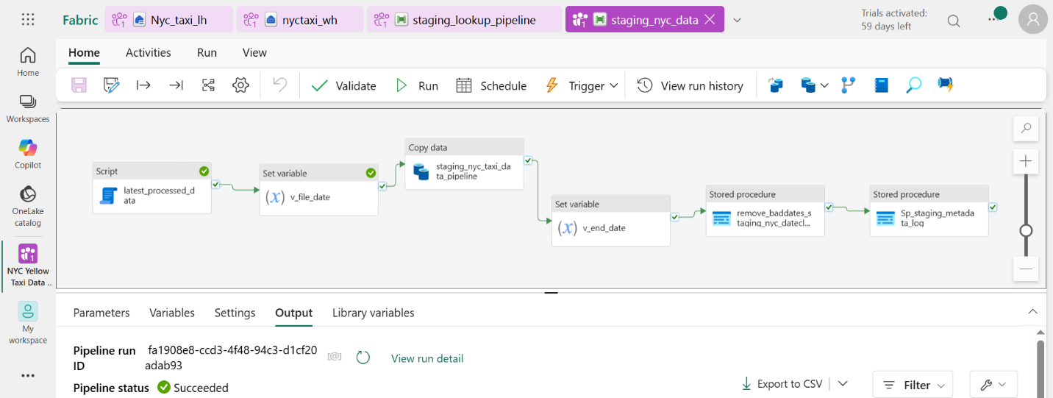

- Next use Dataflow gen2 to perform cleansing and transformations on taxi zone lookup and taxi data tables from staging layer.
- Create a dbo.pres_nyc_taxi_data table:

CREATE table dbo.pres_nyc_taxi_data
(
vendor VARCHAR(50),
tpep_pickup_datetime date,
tpep_dropoff_datetime date,
pu_borough VARCHAR(100),
pu_zone VARCHAR(50),
do_zone VARCHAR(50),
do_borough VARCHAR(100),
payment_method VARCHAR(50),
passenger_count int,
trip_distance float,
total_amount FLOAT
);

- Now create a dataflow pres_nyctaxi_processing_dfl2 -> add source-> warehouse, select nyc_taxi_data and perform cleaning and transformations on the table.
- Now we will combine both the tables data and load into Presentation layer in Datawarehouse which can be used for creating semantic models.

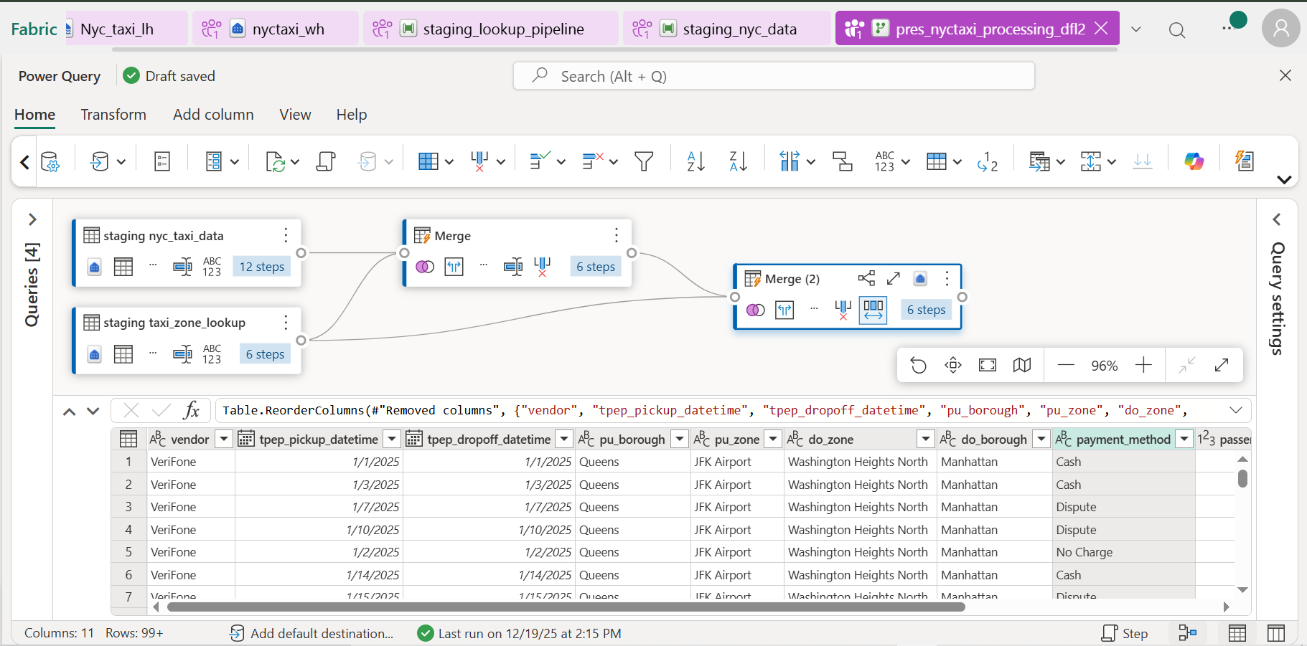
- Create a Stored Procedure metadata.insert_pres_log using presentation table and this to dataflow activity:
CREATE procedure metadata.insert_pres_log
@pipeline_run_id VARCHAR(255),
@table_name varchar(255),
@processed_datetime DATETIME2(5)
AS

INSERT INTO metadata.processing_log(pipeline_run_id,
table_processed,
total_row_processed,
latest_processed_pickup,
processed_datetime)
select
'placeholder'as pipeline_run_id,
'pres_nyc_taxi_data' as table_processed,
count(*) as total_row_processed,
max(tpep_pickup_datetime) as latest_processed_pickup,
CURRENT_TIMESTAMP as processed_datetime
from dbo.pres_nyc_taxi_data;

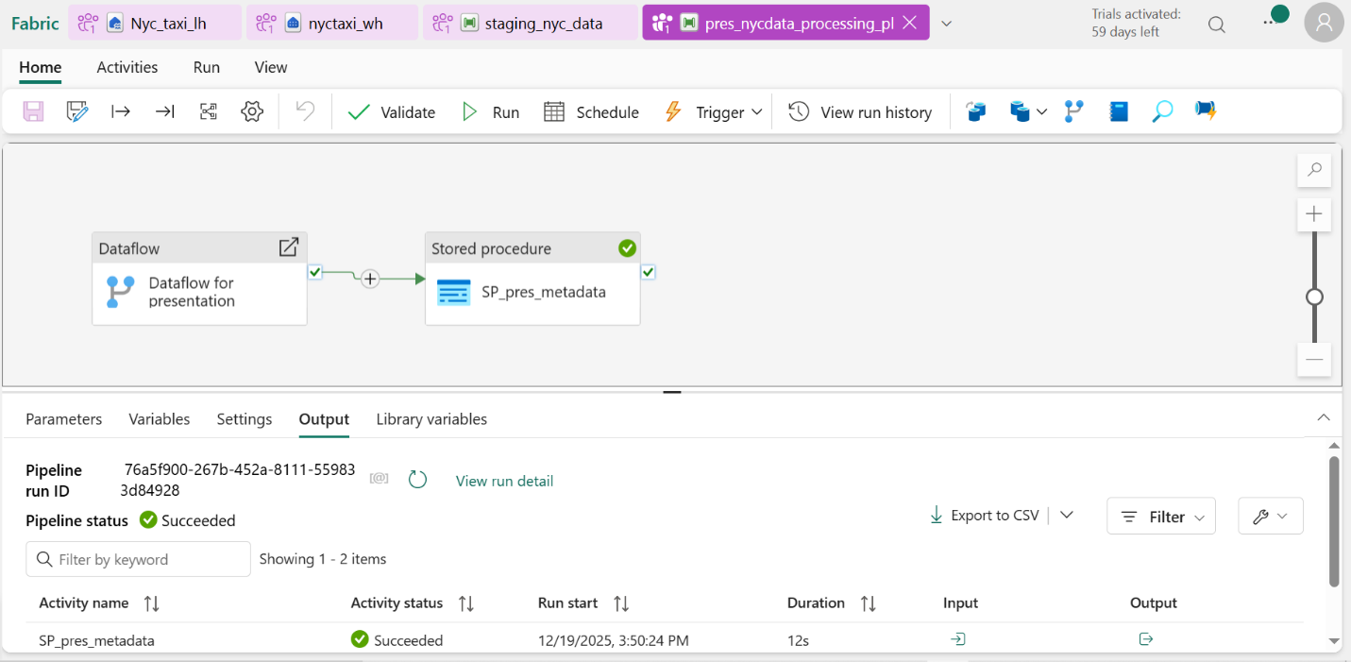

- Create an orchestration pipeline to invoke both the staging pipeline and presentation pipeline to run one after the other.

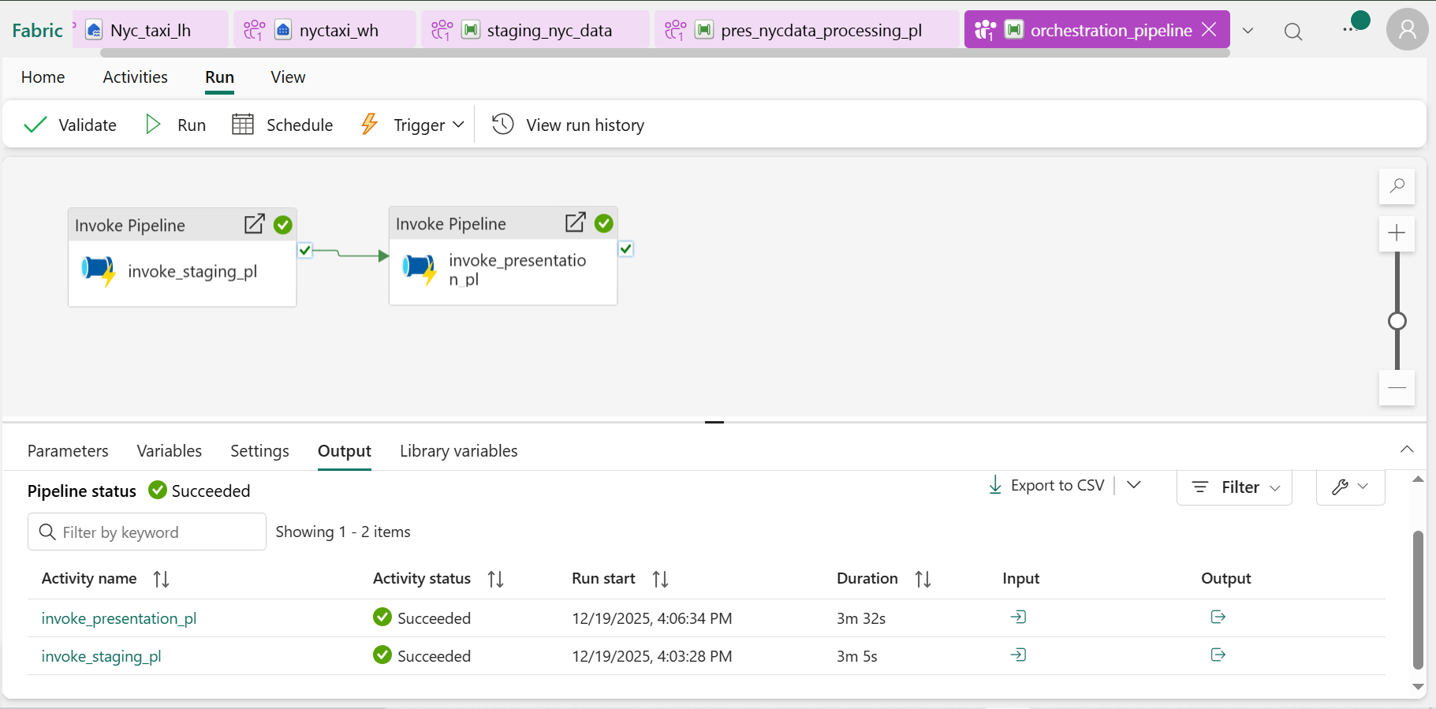

- Replace Dataflow Gen2 activity with stored procedure to demonstrate how stored procedure is more efficient.
- Expose the data from warehouse and build semantic model to create visualizations in Power BI.
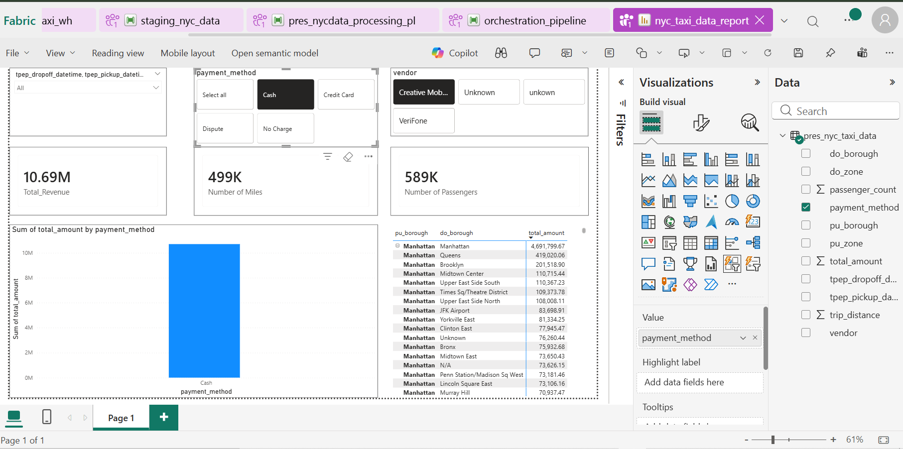

- Now replace the dataflow in (pres_nyc_dataprocessing_pl) pipeline with stored procedure to increase the efficiency.
- Create a Stored Procedure (dbo.orchestration_presentation) in the Data Warehouse using the following code:

CREATE PROCEDURE dbo.orchestration_presentation
AS
INSERT INTO dbo.pres_nyc_taxi_data
SELECT
CASE
WHEN nty.VendorID = 1 THEN 'Creative Mobile Technologies'
WHEN nty.VendorID = 2 THEN 'VeriFone'
else 'Unknown'
end as vendor,
format(nty.tpep_pickup_datetime,'yyyy-MM-dd') as tpep_pickup_datetime,
format(nty.tpep_dropoff_datetime,'yyyy-MM-dd') as tpep_dropoff_datetime,
lu1.Borough as pu_borough,
lu1.Zone as pu_zone,
lu2.Borough as pu_borough,
lu2.Zone as pu_zone,
CASE
WHEN nty.payment_type = 1 THEN 'Credit Card'
WHEN nty.payment_type = 2 THEN 'Cash'
WHEN nty.payment_type = 3 THEN 'No Charge'
WHEN nty.payment_type = 4 THEN 'Dispute'
WHEN nty.payment_type = 5 THEN 'Unknown'
WHEN nty.payment_type = 6 THEN 'Voided Trip'
else 'Unknown'
end as payment_method,
nty.passenger_count as passenger_count,
nty.trip_distance as trip_distance,
nty.total_amount as total_amount
from staging.nyc_taxi_data nty
left join staging.taxi_zone_lookup lu1
on nty.PULocationID = lu1.LocationID
left join staging.taxi_zone_lookup lu2
on nty.DOLocationID = lu2.LocationID;

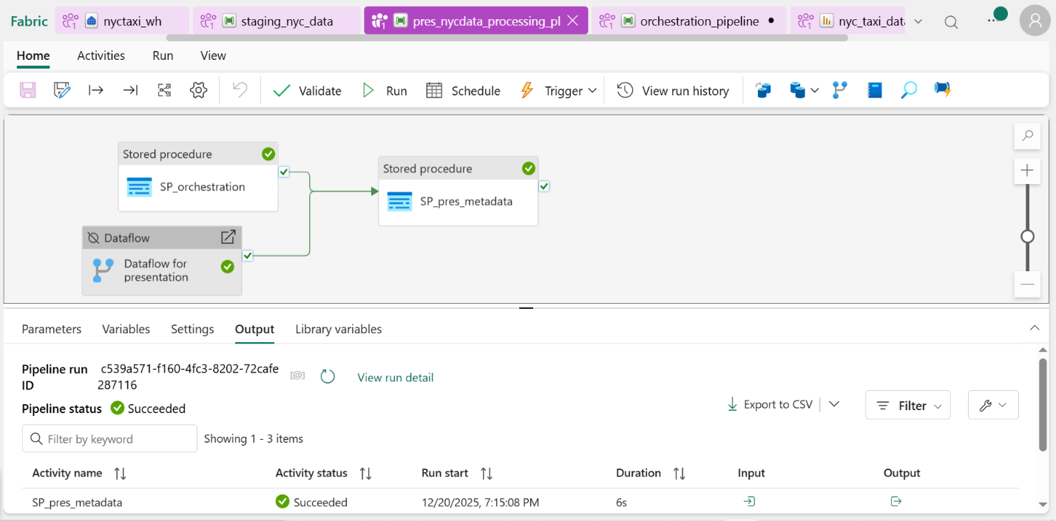

- Go to monitor section to view the history, status and other details of pipeline.

